**Lab 4: Android Application, REST and SOAP Services**

*Sailaja Pedaprolu*

*16157493*

The first task was to develop an android application that would display google map. Google Map API was used for this purpose.

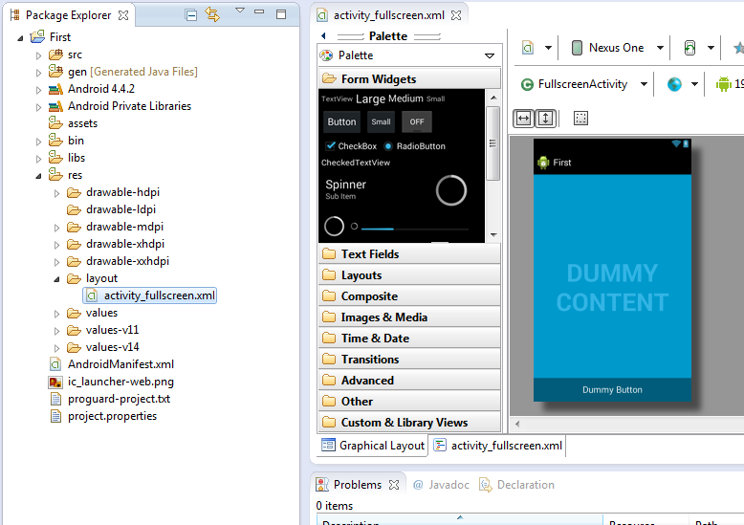

Firstly, Eclipse IDE is installed and using SDK Manager latest packages are downloaded and installed. Linear layout is chosen and androidManifest.xml, activity.xml and .java files are opened. A new android application projectnamely ‘Map’ is built.

Later, Google API features are loaded into the project. It is necessary to generate a Key to use the google services. So to generate a key command prompt is opened and “-tool…” is typed. As we press enter a random sequence of no.s is generated which becomes the authentication key. This key is entered in the google key generator under android key tab followed by app name.

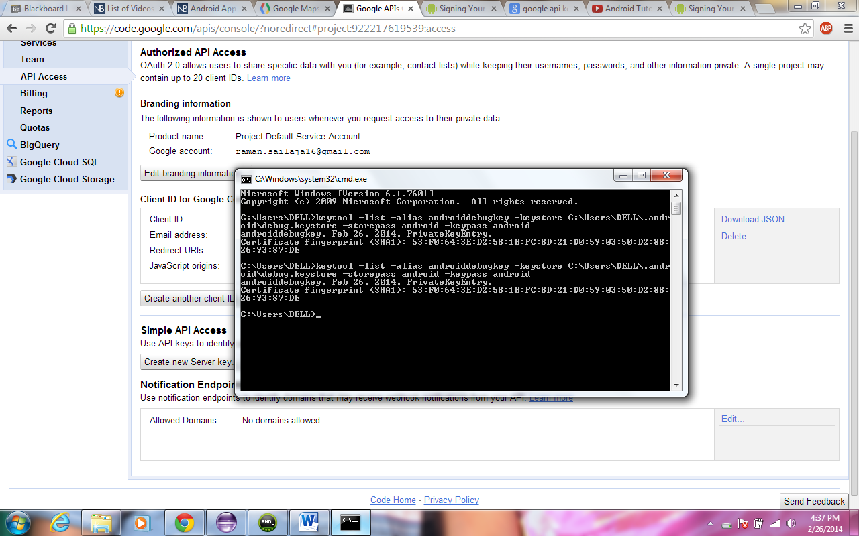

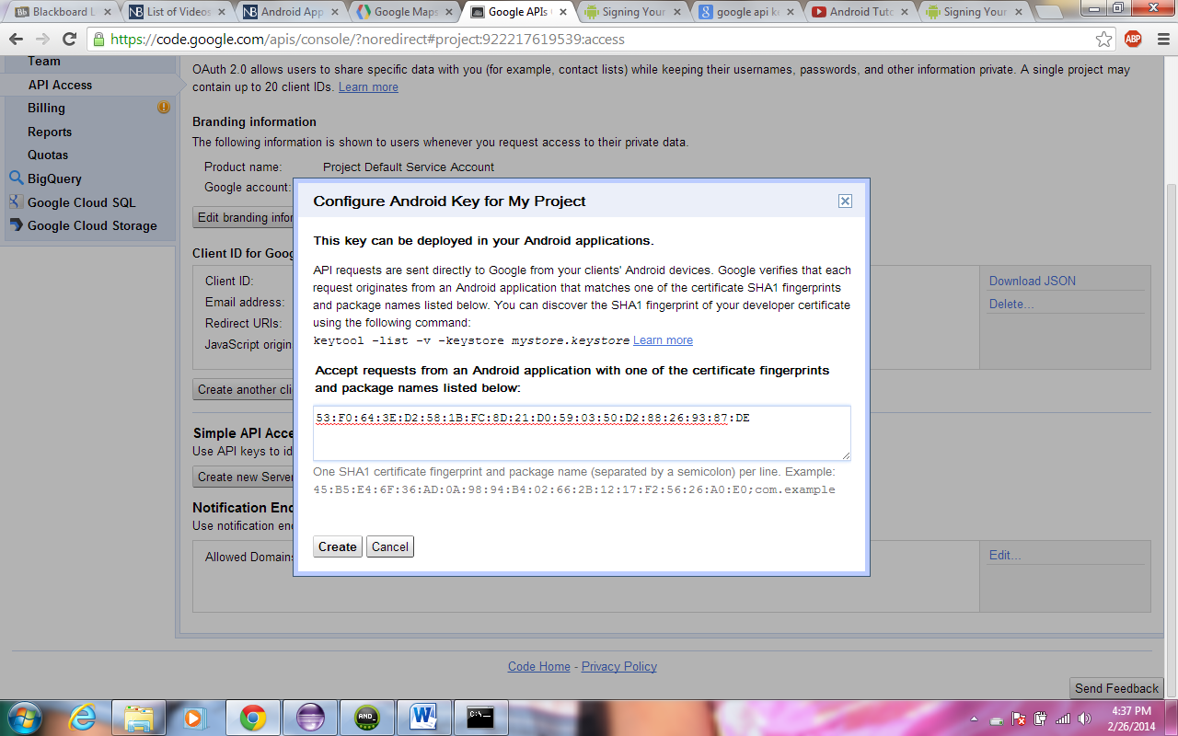

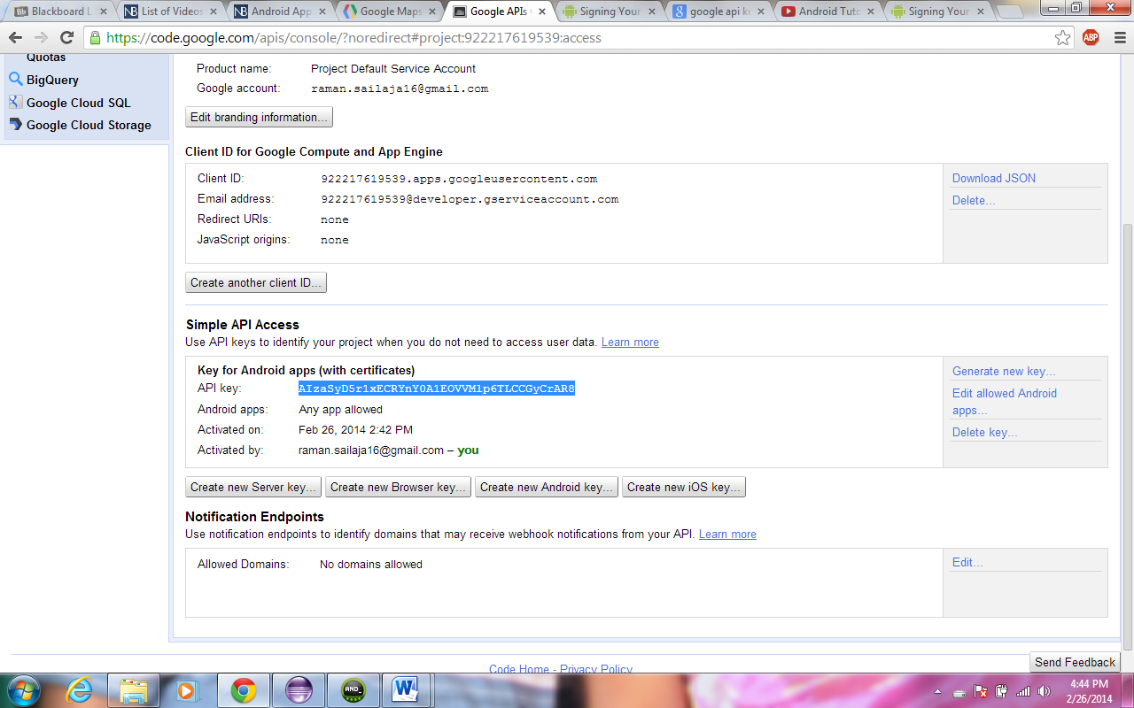

The generated key is added to the .xml code under activity.

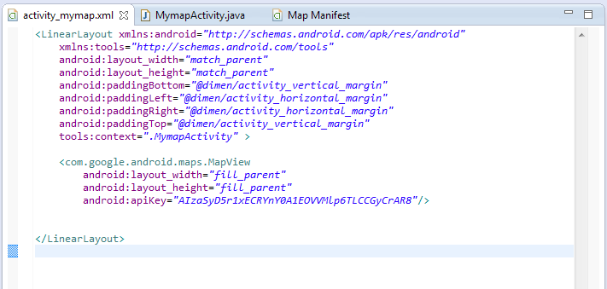

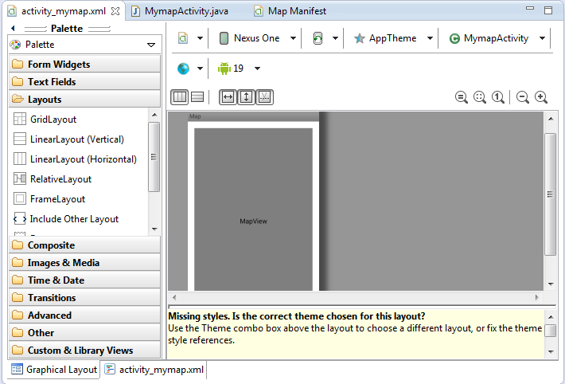

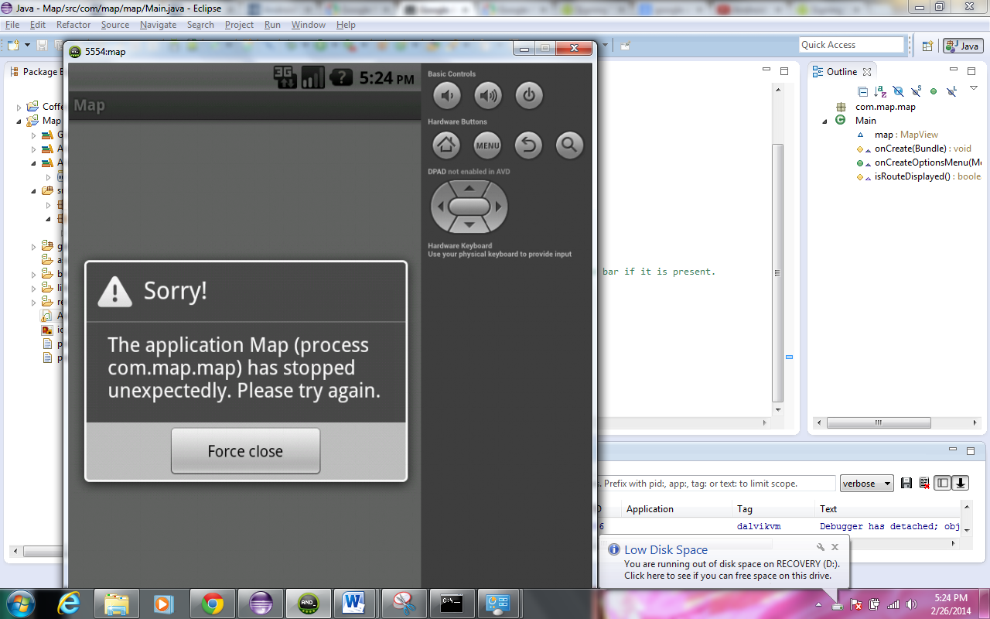

**Rest Service:** A service that displays the names of city, state and country is designed. First of all, an IIS server is locally installed. Later, a source file is created in visual Studio. When the file is opened using a browser initially nothing appears.

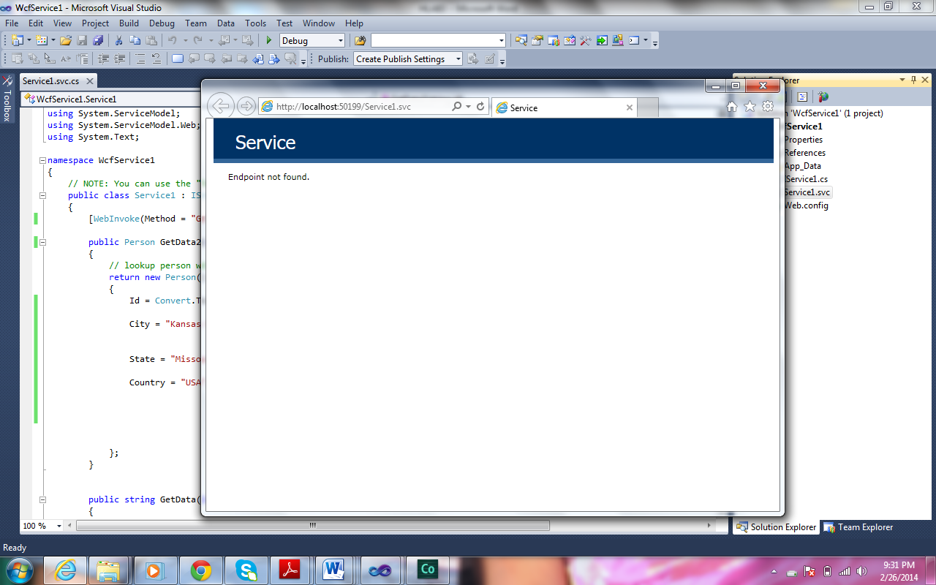

Later when the url is appended with “/data/1”

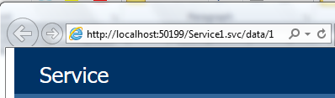

The following result appears. Similarly when several other entries can be retrieved by changing the data number entry.



**Creating a Database:**

A service is created that takes names and phone no.s as inputs and updates a database. Using the MS Visual Studio, the following front end design screen is configured.

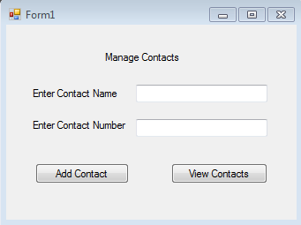

Then the desired information is entered into the text fileds

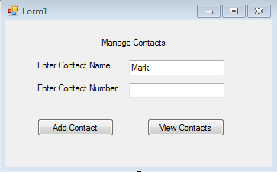

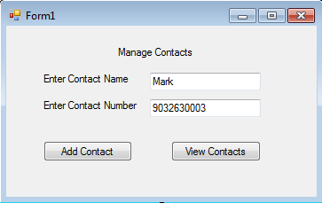

Then, when the “show Contacts” is clicked, the following is displayed.

